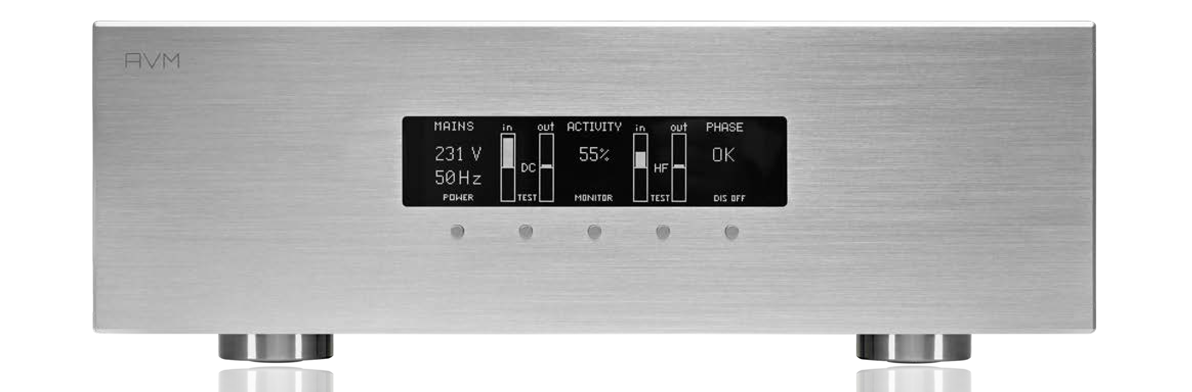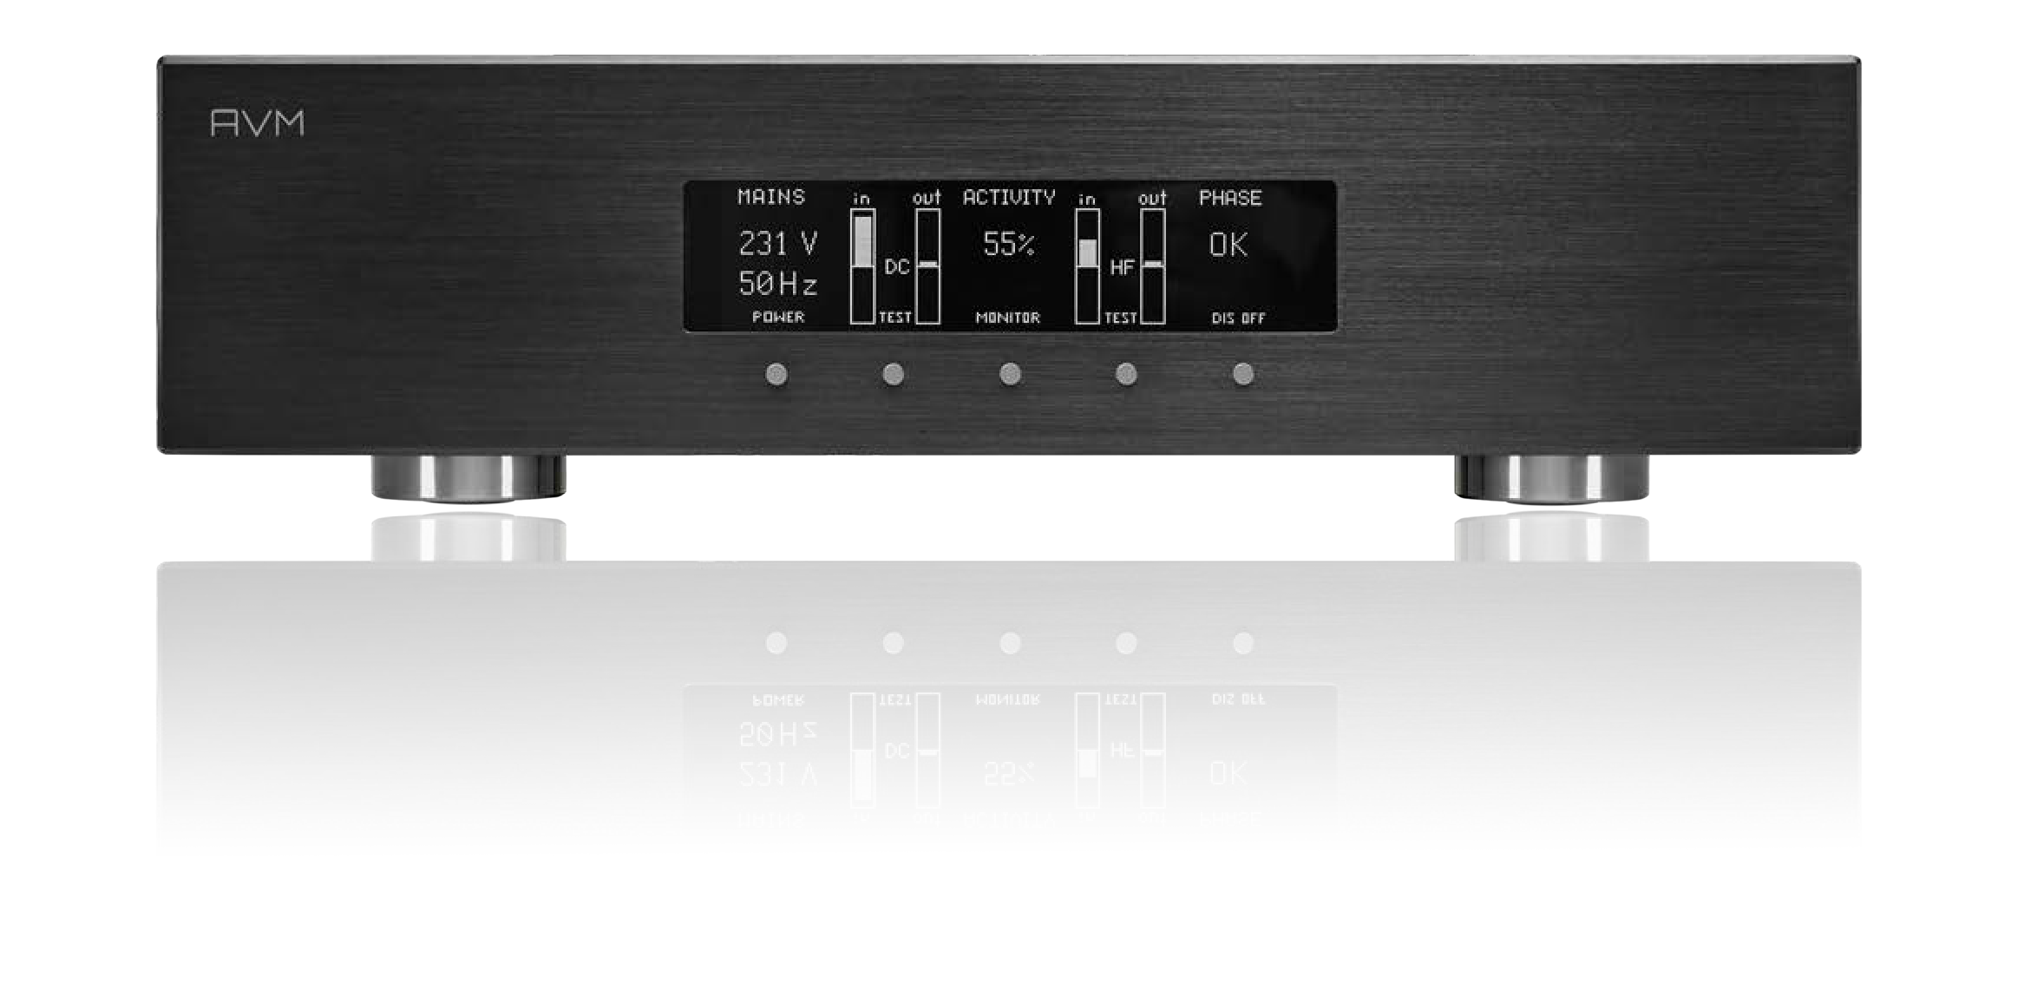

# CONDITION LINE

Power Conditioner with Display

# PC 5.3 & 3.3

#### MAINS CONDITIONING

CONDITION LIN

Power Cond

PC 3.3 AND PC 5.3

* DC filter directly at the device input of the power conditioner removes unwanted DC components from the mains supply, effectively eliminating mechanical transformer hum.
* The individual HF mains filtering with common mode chokes and film capacitors is designed separately for each connection and effectively suppresses mutual interference between the connected devices.
* Crosstalk between the connected devices is efficiently suppressed

#### SAFETY

* Active phase detection at the input: Activation of the outputs is only possible if PE (protective earth) is connected and the mains phase is correct, otherwise an error message is shown on the display
* Overcurrent protection for N and L against PE (protective earth)
* RCD circuit breaker can be operated for resetting on the underside of the device (residual current protection, overcurrent protection), if triggered, the message appears on the display
* Low power outputs for source devices are additionally protected by externally accessible fuses
* Overvoltage protection against up to 6000 A in 30 msec

#### OPERATION

* Conditioner activity is shown in the display (0-100%)
* Conditioner activity is also displayed acoustically when a button is pressed
* The applied power quality is continuously analyzed and displayed (mains voltage & frequency,   
  DC offset, HF)
* Operation of all functions via 5 buttons below the display
* ON / STANDBY can be operated via AVM RC3 or RC 5: Connected devices are switched on with a time delay. The IR sensor can be deactivated if the remote control option is not required
* Power down sequence via remote control: Power down is delayed so that settings of the connected devices can still be saved
* Resettable RCD (residual current device) under the device (easy to feel)
* Main power switch on the rear panel (mains switch)

#### OUTOUTS PC 3.3

* 2 Power Outlets belastbar bis 16A für Voll- und Endverstärker
* 4 Low-Power Outlets belastbar bis 2A für Quellgeräte separat abgesichert (zugänglich auf der Geräterückseite)
* Outputs are switched sequentially (Low-Power / Power1 / Power2) to limit inrush currents, this prevents unintentional tripping of the house fuses

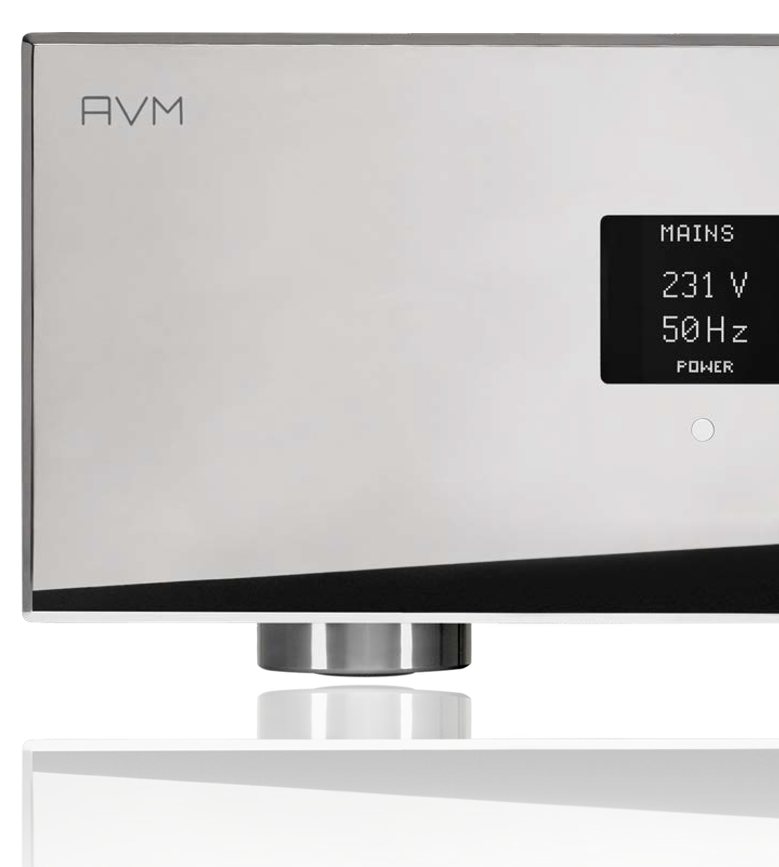

#### DISPLAY

* + 256 x 64 white graphic OLED, can be switched off
  + Mains phase OK / NOT OK
  + Mains frequency 50/60Hz
  + Continuous measurement and display of the mains voltage
  + Continuous monitoring of the power quality on DC in/out,   
    displayed as a bar graph
  + HF components are measured and   
    continuously displayed (bar graph)
  + Numerical display of conditioner activity (0-100%) shows   
    the current load on the correction circuit
  + Acoustic display of the activity via a sound transmitter   
    (acoustiliser), can be activated as required for control purposes
  + Demo buttons for DC and HF: Bridges DC filter and HF filter for   
    direct listener comparison

THE IDEA: WHY 'FILTER' THE ELECTRICITY?

With the PC 3.3 and PC 5.3 power conditioners, we are offering high-end power filter systems for the first time: Mains power filtering and cleaning have been consistently rethought and developed in-house by AVM's most experienced sound engineers. Both low and high-frequency interference is effectively kept away from the audio system and the mutual interference between the precision audio components is effectively prevented by the separate HF filters for each output. Numerous safety functions have been incorporated to protect the valuable components from overvoltage surges or, for example, to ensure correct storage of metadata through time-delayed power-down. We have had the electrical safety of both power conditioner models certified by independent testing institutes.

OUR GOAL:

With the development of the AVM Power Conditioner, we are tackling the problems that prevent current audio/video components from realising their full potential. We simultaneously eliminate high and low frequency mains interference, both of which can be switched off individually to check their effectiveness.

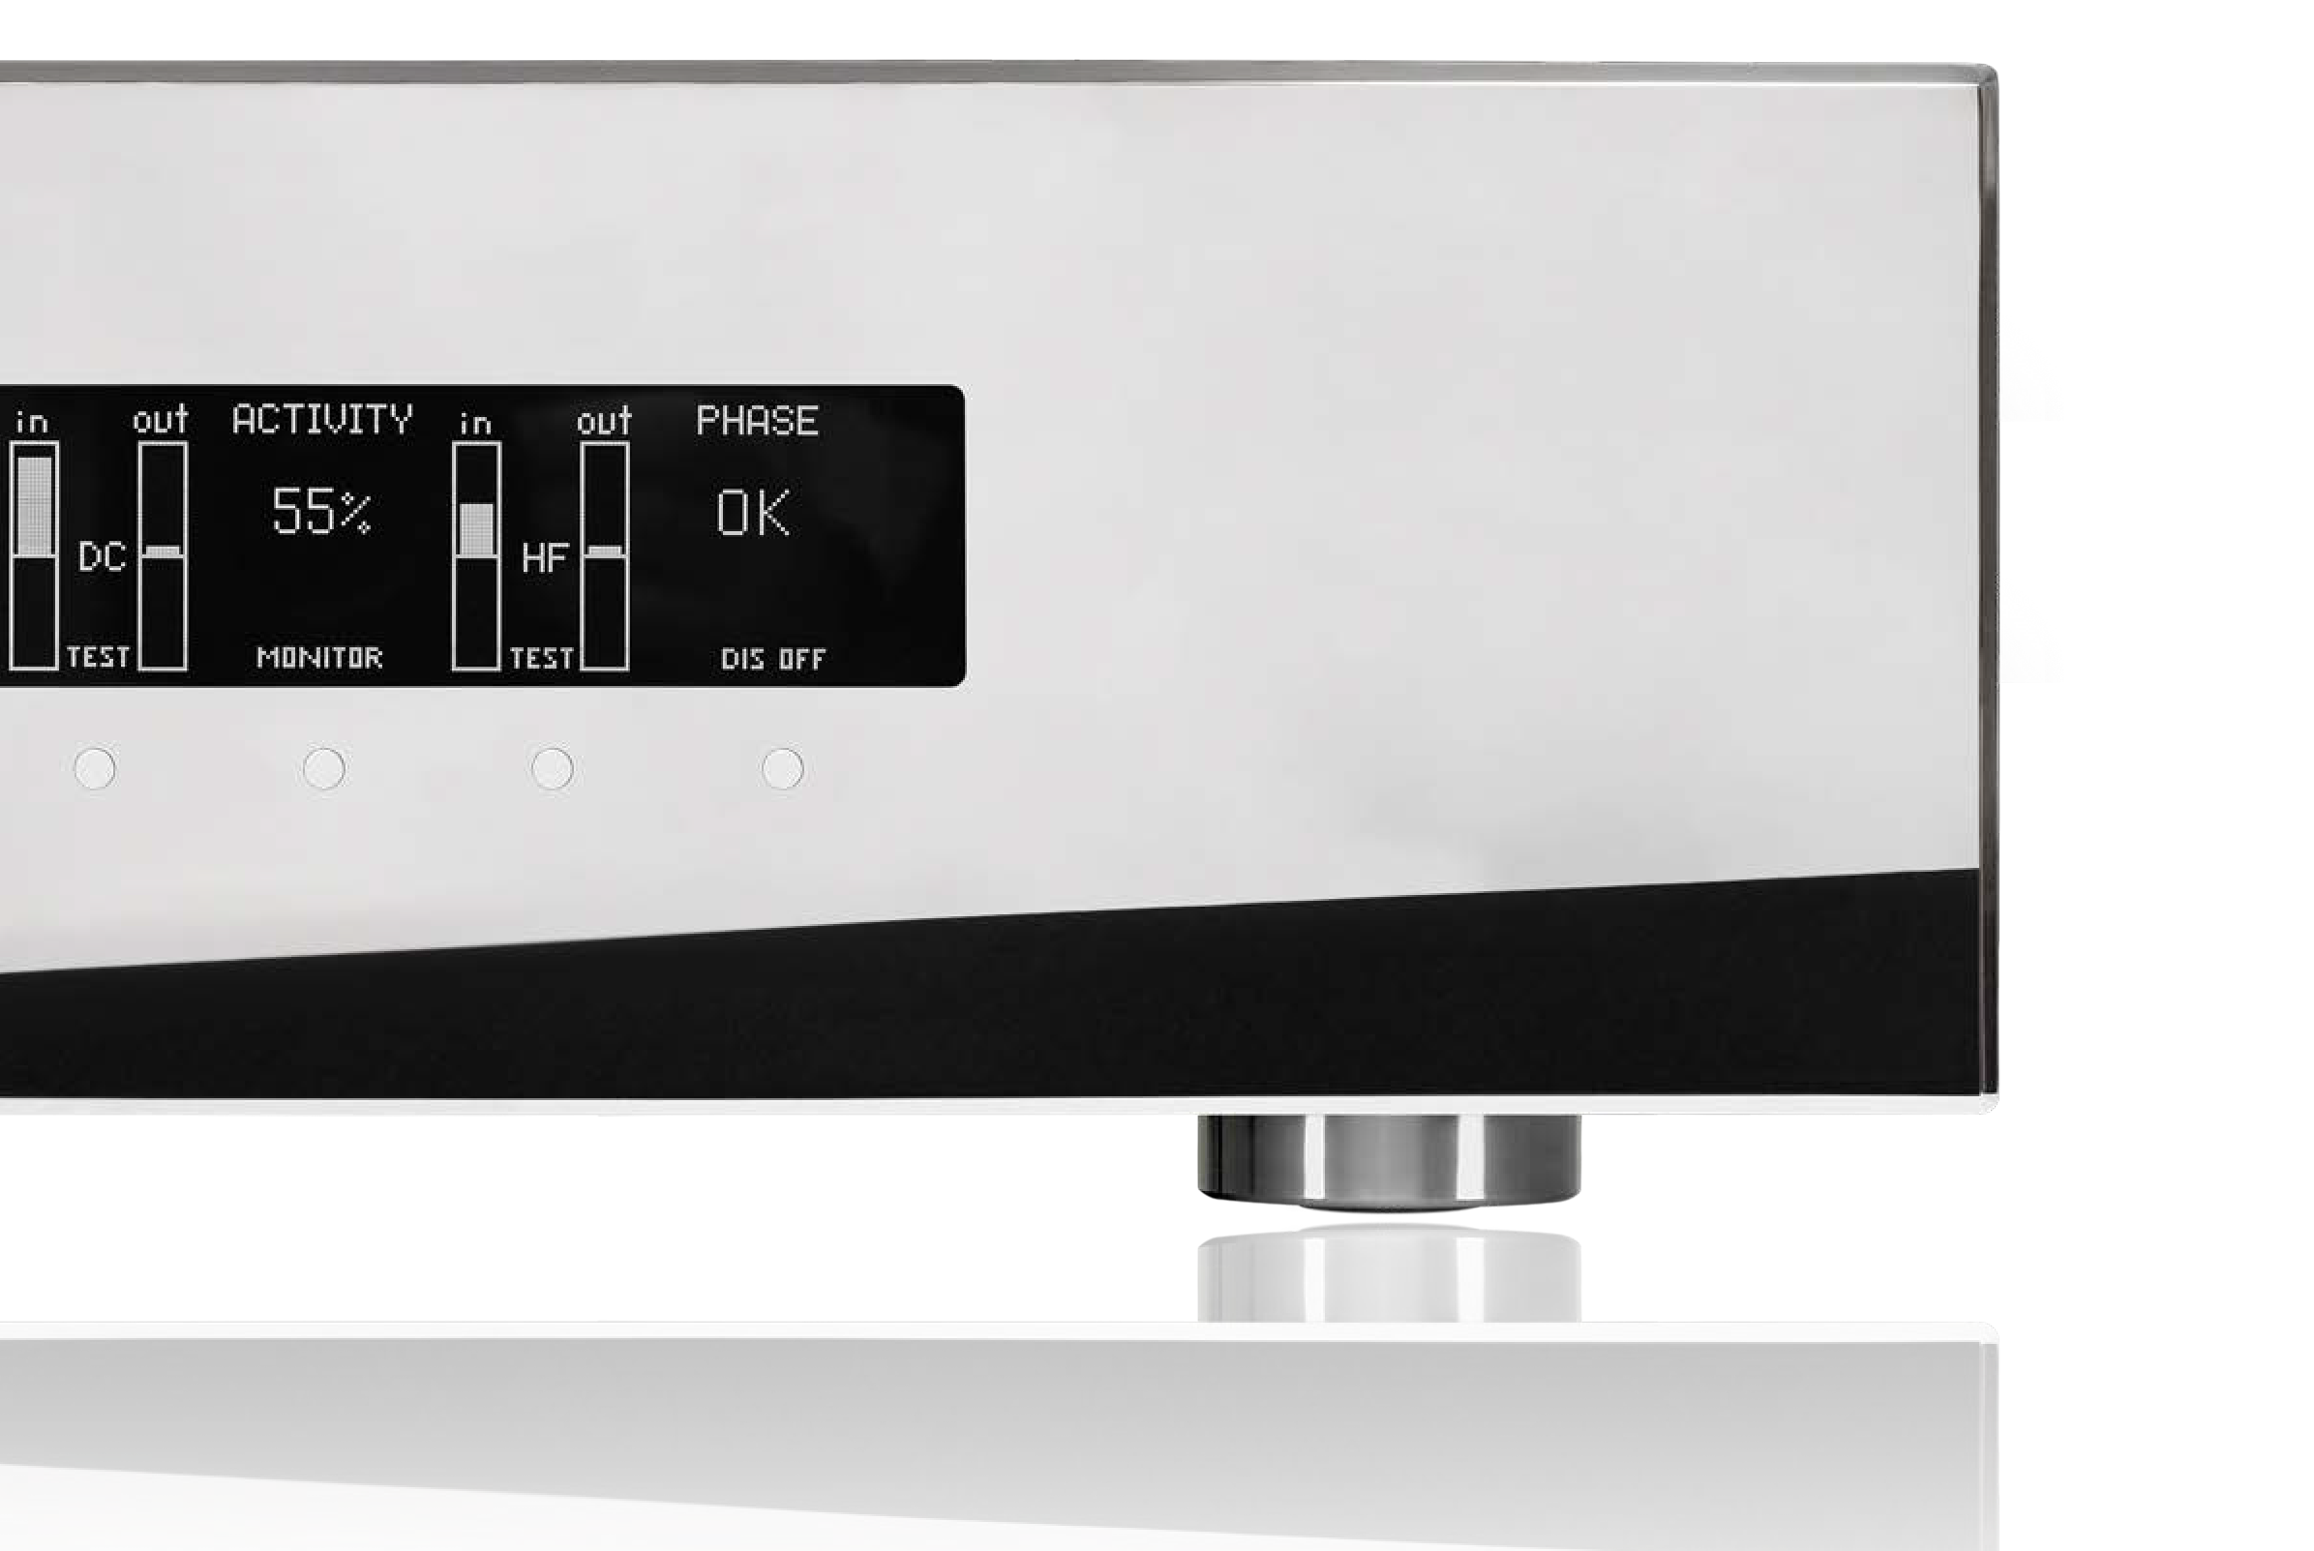

#### MAIN INPUT



E PC 5.3 & 3.3

itioner with Display

IN Keyword

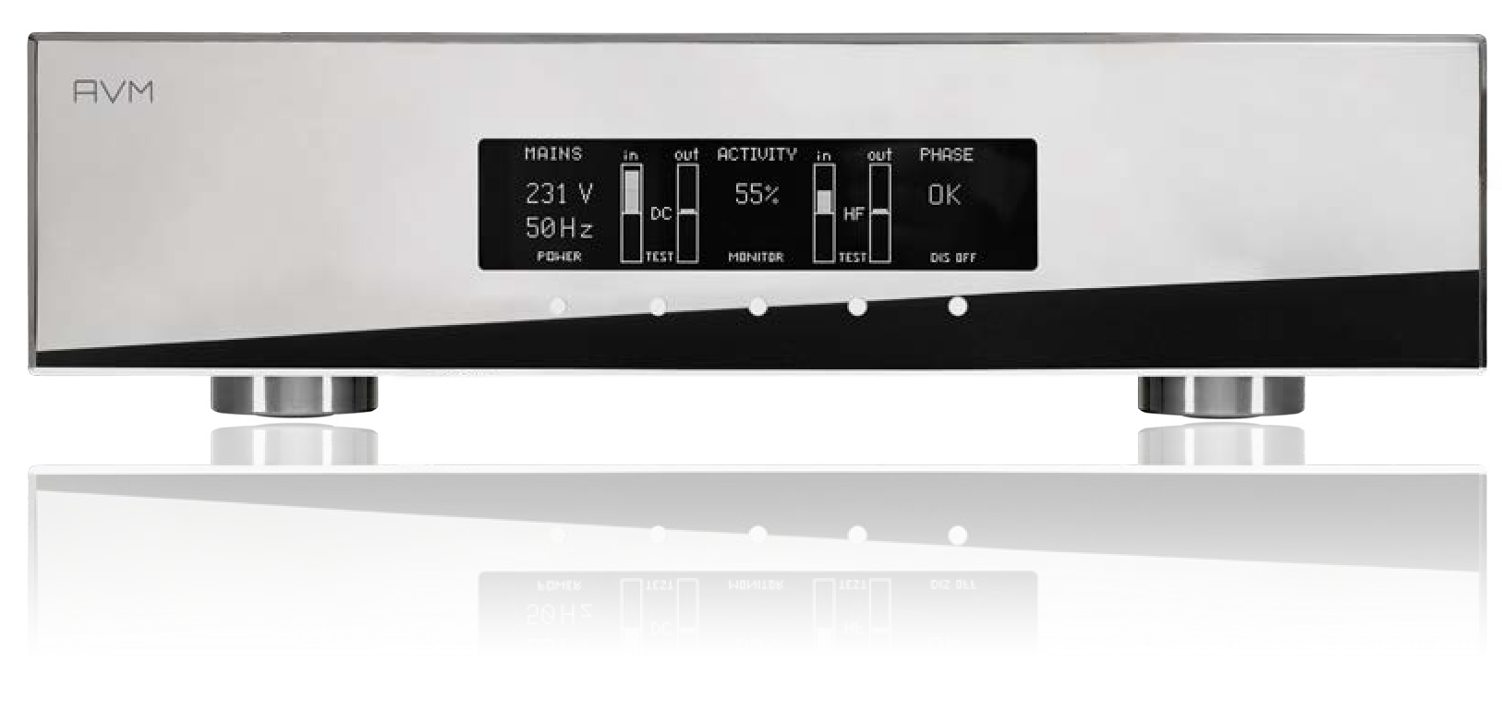

**PC 3.3 CELLINI**

OUTPUTS PC5.3

* + - 16A high current mains socket
    - Mains voltage 230VAC / 50-60 Hz
    - Maximum current 16A (3680W at 230V AC)
    - Standby power consumption << 0.5W16A
  + 4 power outlets loadable up to 16A for integrated and power amplifiers
  + 8 low-power outlets loadable up to 2A for source devices separately fused (accessible on the rear of the device)
  + High Power power supply unit as turntable supply connection 15V DC / 4A (max. 60W loadable), galvanically isolated (PC 5.3 only)
  + Outputs are switched sequentially (Low-Power / Power1 / Power2) to limit inrush currents, this prevents unintentional tripping of the house fuses

**PC 5.3 CELLINI**

The impurities in the supply voltage required for operation, which are already coming from the mains, ultimately lead to noticeable audible sound losses, so that the valuable connected audio components cannot realise their full potential if everything is left unfiltered. In our complex power grids with an enormous number of feeders (solar PV systems with inverters, wind turbines and many decentralised large power plants with extremely long supply paths and multiple transformer changes), HF interferers (data transmission via the power lines), very unpleasant masking effects occur with modern amplifiers and playback devices when the power quality fluctuates greatly during the course of the day. Today, these have an incredible bandwidth and a very wide dynamic range. Only a power supply that is free from the unavoidable interference in the connected audio components enables the reproduction of the best possible sound experience.

As a music lover, you will experience your favourite pieces of music and recordings in the most magnificent transparency, spatiality, dynamics and live-like feel, which brings the reproduction of the recordings even closer to the real live experience because your audio components are finally supplied with pure power.

## CONDITION LINE PC 5.3 & 3.3

CONDITION LINE PC 5.3 & 3.3

Aktive Power Conditioner mit Display

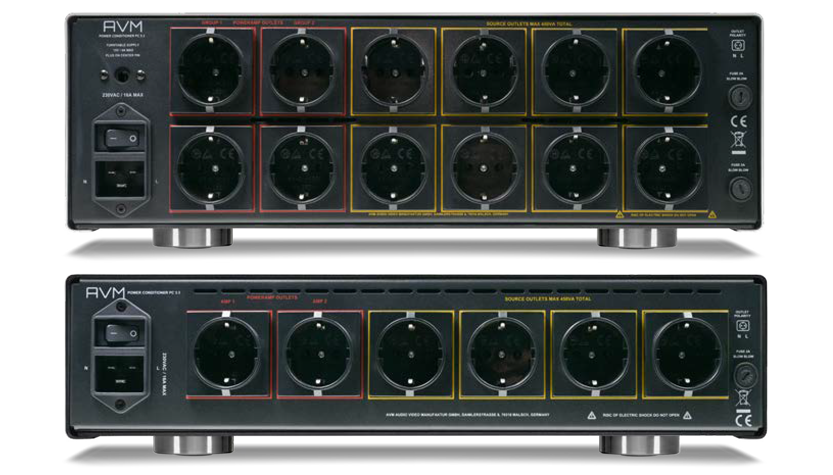

### Power Conditioner with Display

**TECHNICAL DATA CONDITION PC 3.3/5.3**

Outputs

2+4 (PC 3.3) Loadable with maximum 3600W

4+8 (PC 5.3) (limited by built-in 16A-RCD)

Voltage version available 240V 50/60Hz

Turntable Power supply (PC 5.3) 15V DC 4A, galvanically isolated

General information

Power 230V/50Hz

Power consumption max. 3,65kW

Standby <<0,5W

Fuse (slowblow), 2A

PC 3.3

Dimensions (B x H x T) 430 x 115 x 380 mm

Weight 9 kg

PC 5.3

Dimensions (B x H x T) 430 x 150 x 380 mm

Weight 13 kg

Garantie 2 years + 2 years for online registration

(Guarantee periods may vary in other sales countries)

AVM Audio Video Manufaktur GmbH, Daimlerstrasse 8, D-76316 Malsch, Tel.: 07246 30991-0, [www.avm.audio](http://www.avm.audio/) Version: 7/2024. Subject to errors, changes to technical data and equipment in the course of product maintenance

AVM Audio Video Manufaktur GmbH, Daimlerstrasse 8, D-76316 Malsch, Tel.: 07246 30991-0, [www.avm.audio](http://www.avm.audio/)

Stand: 6/2024. Irrtum, Änderungen an technischen Daten und Ausstattung im Zuge der Produktpflege vorbehalten